Eligibility | Post-secondary Educational Benefits for Foster Care and Adopted Youth
Youth in foster care/under state guardianship anytime since turning age 13 | Independent status:  - Determined by each student’s post-secondary program based on the Free Application for Federal Student Aid (FAFSA).  - Post-secondary programs may request documentation confirming foster care placement/state guardianship from the student’s social worker.  - Students do not have to include their parents/adoptive parent’s information/income on the FAFSA.  - Students receive the maximum amount of federal Pell Grant.  - Students answering yes to one of the following questions, can be considered independent students.  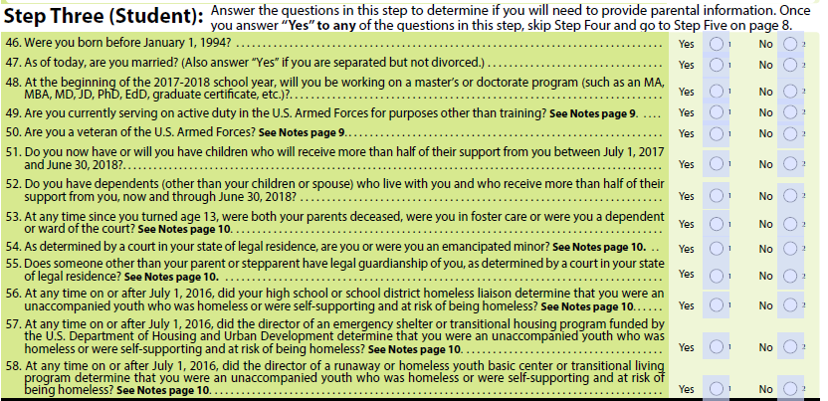
Youth in foster care or left foster care for adoption or transfer of custody or under state/tribal guardianship | MN Education and Training Voucher (ETV) program:  Eligibility criteria: Youth under age 21, graduated from high school or received a General Educational Development (GED) diploma, accepted into an accredited institution of higher education, awarded financial aid, such as the federal Pell Grant or Minnesota State Grant, and one of the following:  - In foster care for 30 consecutive days or more between their 17th and 18th birthdays, or (NOTE: For the 2018-19 school year, this criteria is changing to ‘in foster care for 30 consecutive days or more on/after their 16th birthday’).  - Adopted, including customary adoptions, from foster care after their 16th birthday, or  - In foster care on or after age 16 when the court ordered transfer of permanent legal and physical custody to a relative, or  - Under state guardianship or tribal guardianship at age 18.  Students can continue to apply each year they need funds for undergraduate or graduate education, if they participated in the ETV program on their 21st birthday and have not reached their 23rd birthday, continue to attend an accredited federal Pell Grant eligible institution of higher education and are making progress in completing their degree.  Application: Students submit on online application each year they need funds up to their 23rd birthday.  Application due dates: Applications are accepted July 1 to June 1.  Resources: Program Guidelines for application checklist and instructions and Expense Guidelines for what ETV funds cover.
Youth under age 21 and under state/tribal guardianship | Tuition waiver for students under state guardianship: Students under age of 21 who are under the guardianship of the commissioner of human services or for an American Indian child under suspension of parental rights or termination of parental rights under the guardianship of a tribe or tribal social service agency. These persons must be qualified for admission to a Minnesota state college or university.  - Students request a tuition waiver from their post-secondary programs.  - Post-secondary programs may request documentation from the student’s social worker confirming state guardianship.
Youth from foster care or adopted meet criteria | Foster Care to Success scholarship:  Eligibility criteria:  - Have been in public or private foster care for the 12 consecutive months leading up to and including their 18th birthday; OR have been adopted or placed into legal guardianship after their 16th birthday; OR have been orphaned for at least one year at the time of their 18th birthday and not subsequently adopted  - Be under the age of 25 on March 31 of the year in which they apply if they have not previously received scholarship funding from Foster Care to Success  - Have been in foster care or orphaned while living in the United States. U.S. citizenship is not required.  - Have been accepted into or expect to be accepted into an accredited, Pell-eligible college or other postsecondary school  - NOTE: This is an undergraduate scholarship only.
Youth meeting income eligibility | SAT fee waiver: Available to low-income 11th and 12th grade students in the U.S. or U.S. territories. U.S. citizens living outside the U.S. may be able to have test fees waived. SAT Subject Test fee waivers are available for students in grades nine through 12. See website for additional criteria.
Extended foster care for youth ages 18-21
Youth in foster care immediately prior to their 18th birthday may continue in foster care past age 18 | Extended foster care for youth ages 18-21:  Youth in foster care immediately prior to their 18th birthday may continue in foster care past age 18 if they desire to continue in foster care and are not able to return home, or otherwise achieve permanency prior to age 18. They must meet at least one of the following conditions on an ongoing basis. A youth must be:  • Completing secondary education or a program leading to an equivalent credential such as a General Education Development (GED) diploma or certificate  • Enrolled in an institution that provides post-secondary or vocational education  • Participating in a program or activity designed to promote or remove barriers to employment  • Employed for at least 80 hours per month  • Incapable of doing any of the above activities due to a medical condition.
Scholarships
See MN Office of Higher Education website | Scholarships offered by MN institutions
MN resident who is 1/4th or more American Indian | MN Indian Scholarship: Award amount is based on need up to $4,000 per year for undergraduate students and up to $6,000 for graduate students.
See website | American Indian Tuition Waiver: Morris
Meet family income and graduate from a Minneapolis, St. Paul, surrounding suburban school | Power of You:  - Offered at Minneapolis Community and Technical College, Century College, St. Paul College and Metropolitan State University.  - The program covers the cost of tuition and fees for two years or up to 72 credits.  - See websites for details.

Created by Jill Von Holtum, MN Education and Training Voucher (ETV) coordinator, MN Department of Human Services, at jill.von.holtum@state.mn.us or 651-431-4663, on Jan. 17, 2018

